
Mentor-Sachin
Team Member
1.Naman Gandhi
2.Paras Rajain
3.Vishal Mishra
4.Sahil Gangwar
5.Mishthi
Insurance FAQ Chatbot

Hackathon Project
Team-3

Section | Title
1. | Project Overview
2. | System Architecture
3. | Technology Stack
4. | User Flow
5. | Admin Flow
6. | Data Flow
7. | Security Architecture
8. | VAPT Overview
9. | SAST Overview
10. | Inputs & Outputs
11. | Design Decisions
INDEX

Project Architecture & System Report

1. Project Overview
1.1 Purpose of the Application
The application is an AI-powered insurance chatbot designed to provide accurate, context-aware responses to user queries related to insurance products and policies. It leverages a Retrieval-Augmented Generation (RAG) architecture to combine semantic document retrieval with large language model (LLM) reasoning, ensuring reliable and grounded answers derived from official policy documents.

1.2 Core Problem It Solves
Insurance policy documents are typically lengthy, complex, and difficult for users to navigate. This application simplifies information access by enabling users to ask natural language questions and instantly receive relevant, document-backed answers, significantly improving usability, efficiency, and user understanding.

1.3 Target Users
The system is designed for two primary user groups:
- End Users / Customers
  - Register and authenticate securely
  - Ask insurance-related questions through a conversational interface
  - Receive accurate, policy-grounded responses
- Administrators
  - Manage and curate the knowledge base
  - Upload and process insurance policy documents
  - Control document availability for chatbot responses

1.4 High-Level System Design
The project is implemented as a decoupled web application with a modern frontend and a robust backend that orchestrates the AI workflow.
- Frontend
  - React-based Single Page Application (SPA)
  - Handles authentication, chat interaction, and administrative workflows
- Backend
  - FastAPI-based REST API
  - Manages authentication, authorization, document processing, and AI inference
- RAG Pipeline
  - User queries are embedded and matched against a vector database
  - Relevant document chunks are retrieved and re-ranked
  - A Large Language Model (llama-3.1-8b-instant) generates final responses using retrieved context

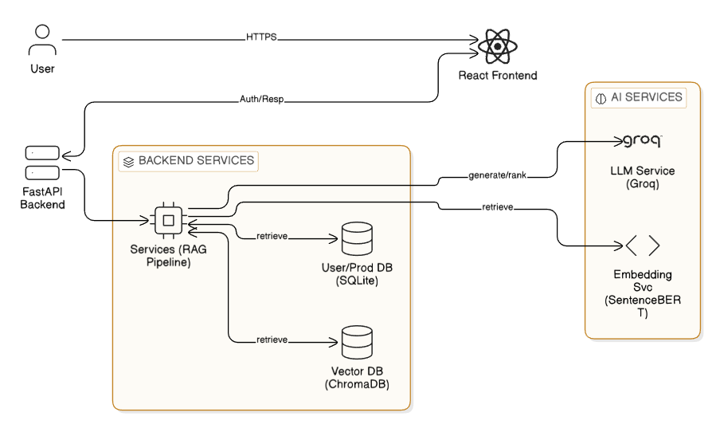

2. System Architecture
2.1 Overall Architecture Style
The application follows a Layered, Service-Oriented Architecture, promoting modularity, separation of concerns, and maintainability. The system cleanly separates presentation, business logic, and data access layers.
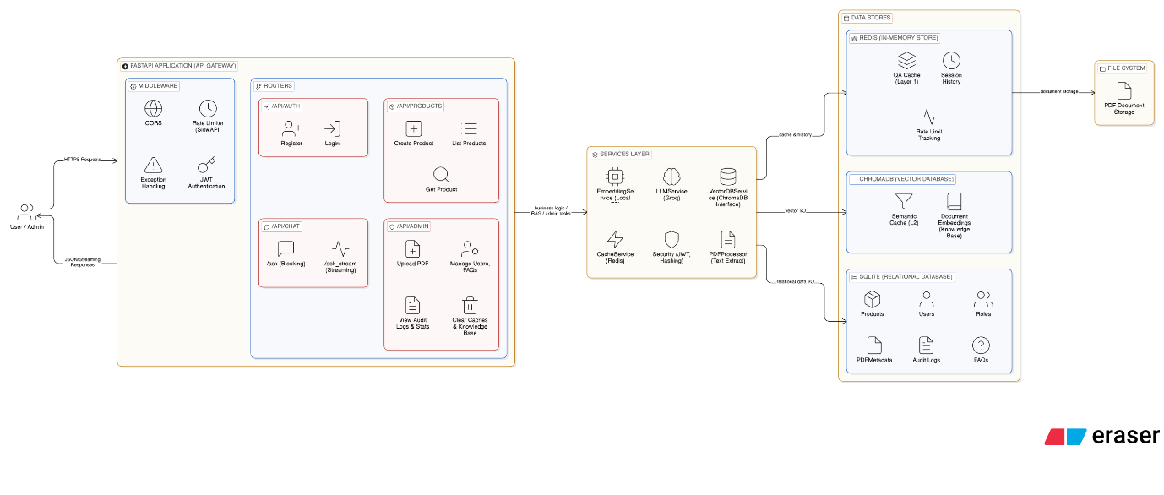

2.2 Backend Architecture
The FastAPI backend is structured using industry-standard best practices:
- Routes / Controllers (/api/routes)
  - Define REST endpoints for authentication, chat, and administration
  - Perform request validation using Pydantic schemas
- Services (/services)
  - Encapsulate core business logic
  - Implement the RAG pipeline, document processing, embedding generation, and LLM interaction
- Models (/models)
  - SQLAlchemy ORM models representing users, products, FAQs, and access mappings
- Database Layer (/database)
  - Centralized database connection and session management

2.3 Frontend Architecture
The frontend is a modern React application built with Vite for performance and developer efficiency.
- Components
  - Reusable UI elements and layout structures
  - Route protection for authenticated and admin-only views
- Pages
  - Dedicated views for login, registration, chat, and administration
- Services
  - Centralized API interaction layer for backend communication
- Contexts
  - Global state management for authentication and UI preferences

2.4 Database Architecture
- Relational Database
  - Stores users, roles, products, FAQs, and access control mappings
  - Managed via SQLAlchemy ORM for consistency and abstraction
  - PostgreSQL for storing users,admin,pdfs.
- Vector Database
  - ChromaDB stores document embeddings
  - Enables efficient semantic search and retrieval for the RAG pipeline

2.5 External Services and APIs
- LLM Service
  - Groq API is used for high-performance text generation
- Embedding Service
  - intfloat/multilingual-e5-base
  - Sentence-transformer models generate dense vector representations of text

3. Technology Stack
Backend
- Language: Python 3
- Framework: FastAPI
- ORM: SQLAlchemy
- Database: SQLite,PostgreSQL,Redis
- AI Stack: ChromaDB, Sentence-Transformers, Groq, LangChain
- Security: JWT , bcrypt (passlib)
Frontend
- Language: JavaScript (ES6+)
- Framework: React
- Build Tool: Vite
- Styling: Tailwind CSS
Key Advantages
- High-performance asynchronous backend
- Clean separation of concerns
- Cost-effective local-first AI pipeline
- Modern, responsive frontend experience

4. User Flow
- Registration
  - Users register via a secure form
  - Passwords are hashed before storage
- Authentication
  - Users log in and receive a JWT
  - Token-based authentication secures subsequent requests
- Chat Interaction
  - Authenticated users submit questions
  - Backend executes the RAG pipeline:
    - Query embedding
    - Vector search
    - Context re-ranking
    - LLM-based response generation
  - Responses are streamed for improved user experience

5. Admin Flow
- Admin Authentication
  - Admin users authenticate via role-based JWT claims
- Admin Dashboard
  - Access-controlled administrative interface
  - PDF upload and knowledge base management
- Document Processing
  - Uploaded PDFs are chunked, embedded, and stored in the vector database
  - Newly ingested content becomes immediately searchable

6. Data Flow
- Client requests originate from the React frontend
- Requests are validated using Pydantic schemas
- Business logic is executed in service layers
- Persistent data is stored using ORM models
- AI-generated responses are streamed back to the client
- Consistent JSON-based API communication is maintained throughout
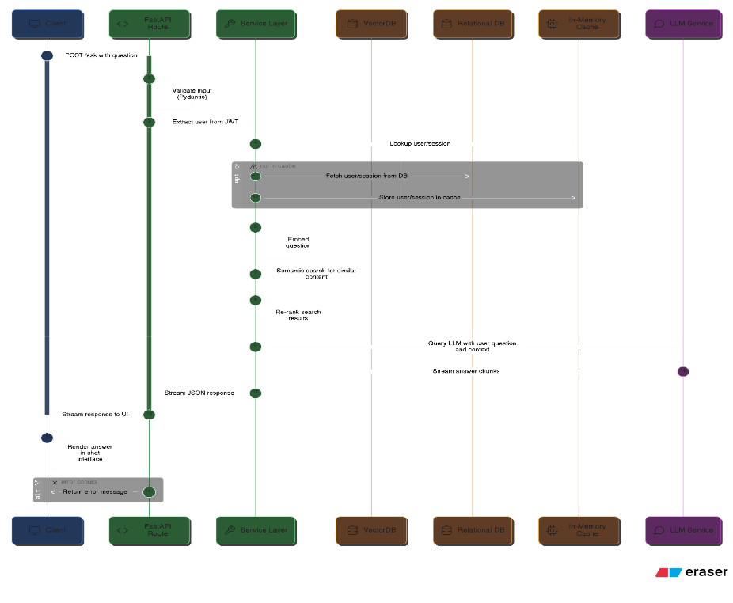

7. Security Architecture
- Authentication
  - JWT-based authentication ensures stateless and scalable security
- Authorization
  - Role-Based Access Control (RBAC) enforces user and admin privileges
- Password Security
  - Secure hashing using bcrypt
- Input Validation
  - Strong request validation via Pydantic models
- API Protection
  - Rate limiting applied to sensitive endpoints

8. VAPT Overview
- Clearly defined attack surfaces are protected via authentication and authorization
- Input validation reduces injection risks
- ORM usage mitigates SQL injection threats
- Prompt handling strategies reduce LLM misuse risks
- File uploads are restricted to controlled admin workflows

9. SAST Overview
- Clean separation of configuration, logic, and data access
- Use of established libraries for cryptography and authentication
- Modular code structure supports maintainability and static analysis
- Centralized services reduce redundancy and improve code clarity

10. Inputs & Outputs
Inputs
- JSON payloads for authentication and chat
- PDF files for document ingestion
- JWT tokens for authorization
Outputs
- JSON API responses
- Streamed chat responses
- Rendered UI components

11. Design Decisions
- FastAPI + React
  - High performance, scalability, and strong developer ecosystem
- RAG Architecture
  - Ensures accurate, explainable, and document-grounded AI responses
- Local Vector Database
  - Enables fast semantic search with minimal infrastructure overhead
- Service-Oriented Design
  - Improves extensibility, testing, and long-term maintainability

